**Team name: Bunch of Morty’s**

**Project Title:**

Visual Arithmetic Solver

**Project Description:**

Using a Raspberry Pi as the main device, a camera is pointed at an arithmetic problem and the result is displayed to the user. This would involve image storage, image processing to a string, parsing of the string, math problem solving, and output to an LCD.

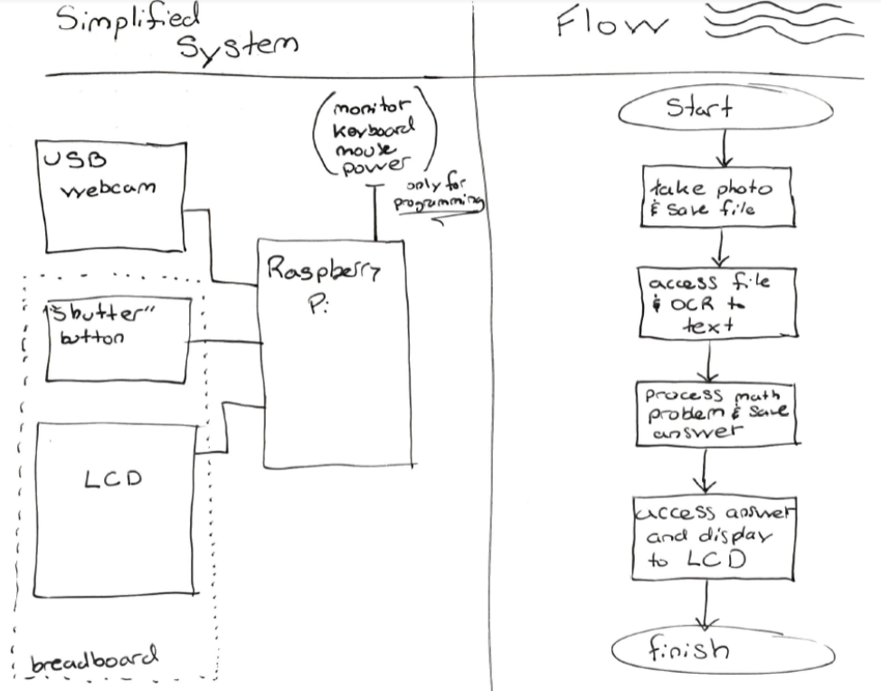

**Gits and team members:**

Andrew Robertson - <https://drewrob35@bitbucket.org/drewrob35/drewrob35.git>

Kaicha Johnson - https://KaichaJ@bitbucket.org/KaichaJ/finalproject.git

Ehsan Halterman - <https://ehsan96696@bitbucket.org/ehsan96696/eh.git>

Abdullah Alfawaz - https://abdullahalfawaz@bitbucket.org/abdullahalfawaz/ab.git

**Lab breakdown:**

Andrew Robertson:

6: Raspberry Pi Tesseract Library

7: -----

8: R Sync

9: *Unrelated* Membrane Keypad

10: *Unrelated* RFID

Kaicha Johnson:

6: Picamera

7:

8: (Unrelated) Plotly Python API

9: (Unrelated)

10: (Unrelated) ADC conversion/SMS

Ehsan Halterman:

6: Storing & Converting Data from Text File.

7: Computing Stored Data/Sending.

8: (Unrelated) Stepper Motor

9: (Unrelated) Midi to USB Conversion I/O

10: (Unrelated) LASER HARP.

Abdullah Alfawaz:

6:Raspberry Pi\ LCD.

7:Raspberry .

8:(Unrelated)wifi bridge.

9:(Unrelated)Laser Trip Wire.

10:(Unrelated)####.